The Enquire Quiz Club has managed a myriad of competitions during the last academic year. The club is very passionate about the quizzing events and also entertains some non-quizzing events as it is the official quizzing, tech, and trivia club of NIT Calicut. The obstacles made the club think big and motivated towards the advancement by transforming them into milestones.

The club has conducted Qflix in May 2020 and Qflix 2.0 in June 2021. It was a competition that aimed at people who loved binge-watching. We have included questions on Friends, La casa de Papel, Game Of Thrones, Stranger Things, and Marvel movies in 2020 and The Office, Harry Potter, Dark, Attack on Titan, and Sherlock in 2021. Prizes worth 2500 rupees were given to the winners each year.

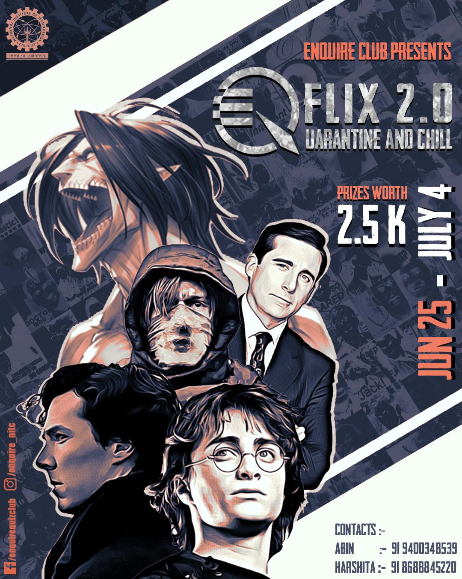

Following the success of “Kryptex“ in 2019, we presented “Kryptex 2.0” in September 2020. In this quiz, contestants should find the answers based on the clues that we had provided. Quizzers had fervently engaged in this event and ended up with giant success. Winners were awarded prizes worth 3000 rupees.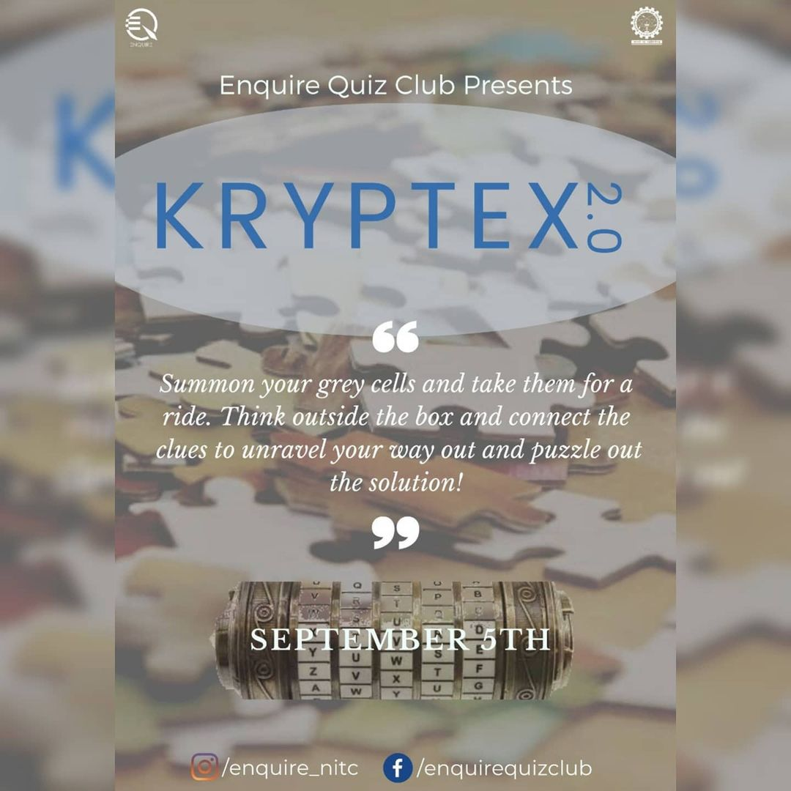

Enquire Quiz club has conducted the Rewind quiz in December 2019 and December 2020 to make quizzers cognizant about all such important moments in the respective years. Qflix, Kryptex, and Rewind are recurring events formulated every year and honor the winners with exciting prizes. 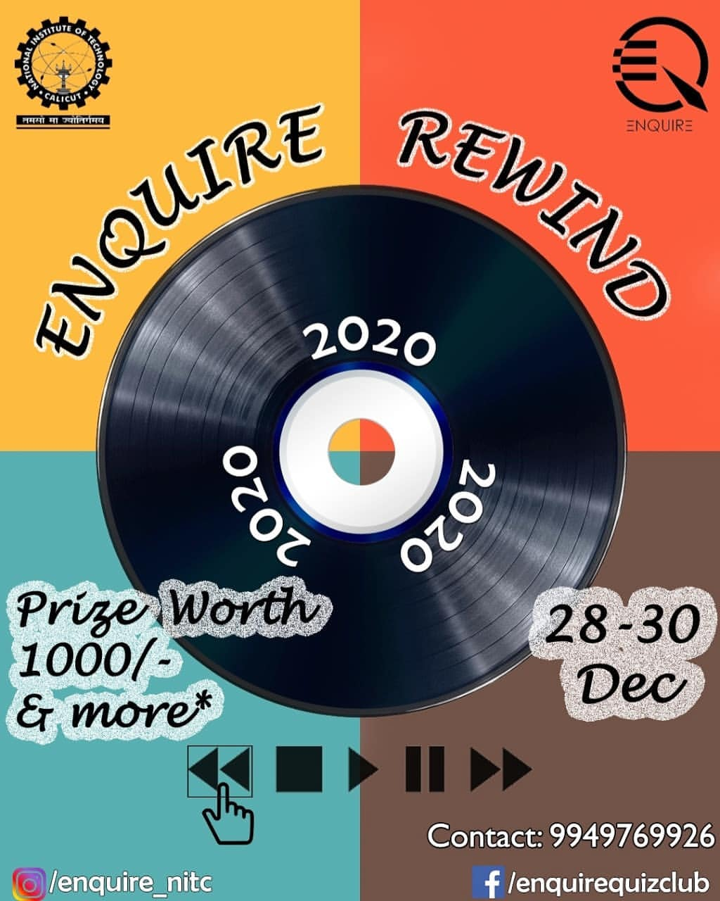

During the IPL season of 2020, our club handled Hat-tricky, which emphasized the cricket admirers about the notable moments in IPL.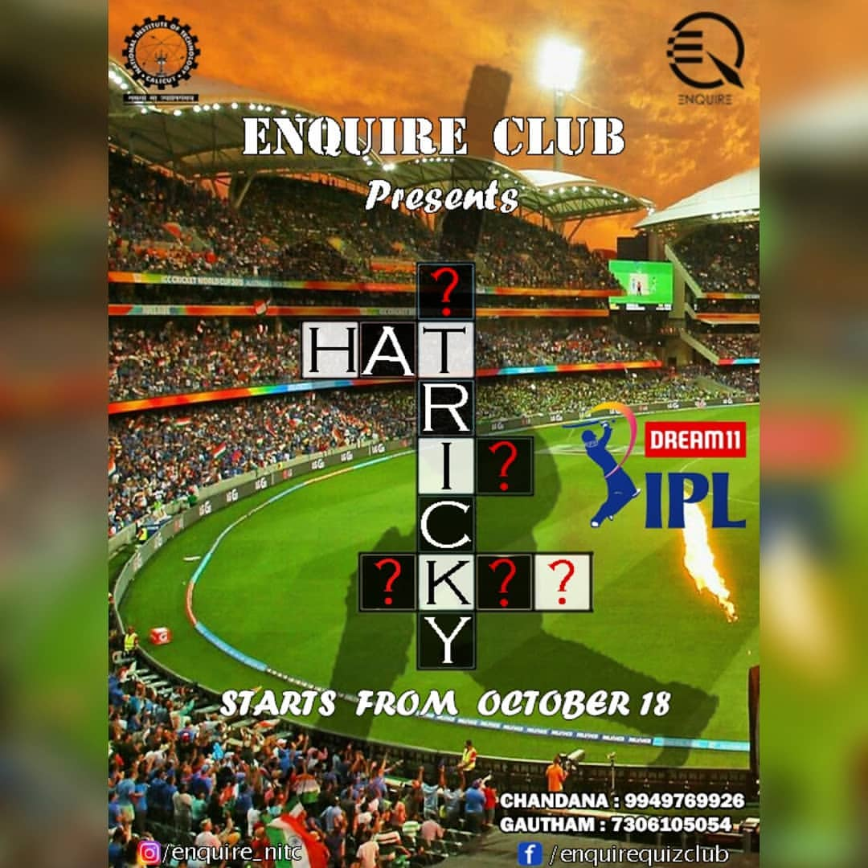

Aloha, an exclusive freshers quiz conducted in February 2020 that went live in college which received a notable mark in the minds of B19's. “Guess Who?”, as the name suggests is a race to identify the picture is conducted in March 2020.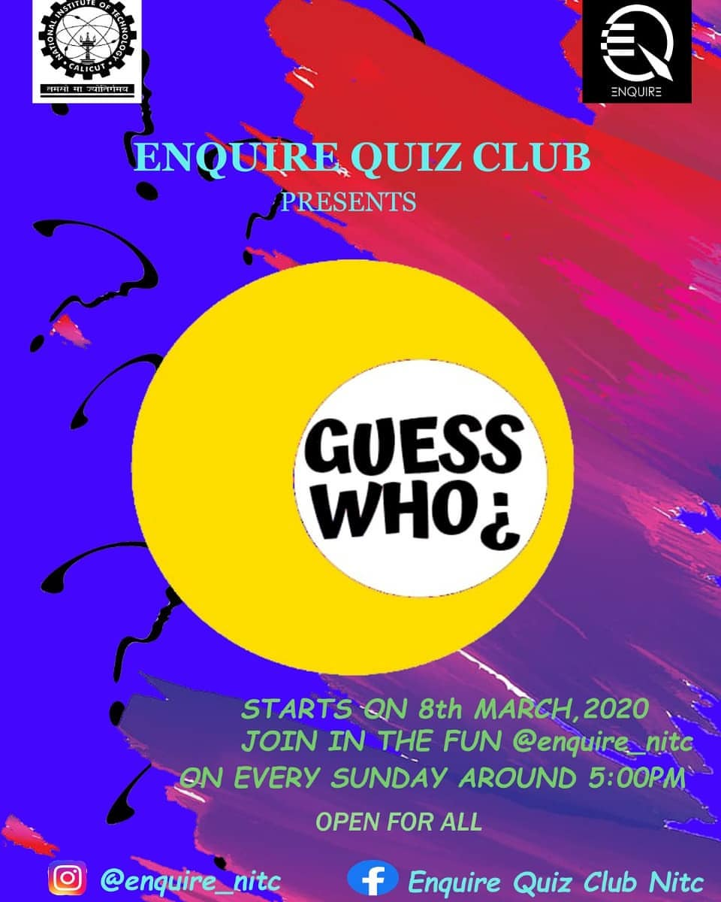

Enquire also formed some non-quizzing events like “Dilse”, a nonquizzing event that gave a chance to our audience to show off their talents in a delightful way.

Formerly “Rhapsody” appeared as a tremendous gala for our fellow juniors, we united them and exhibited the club by organizing the events namely Quriosity, Reverse Quiz, House of Cards, Improvision, and Why so Serious …?

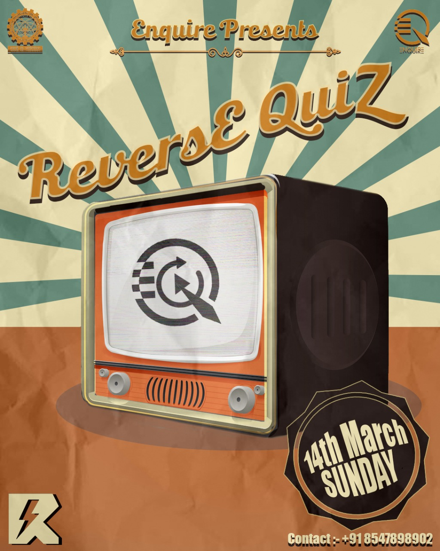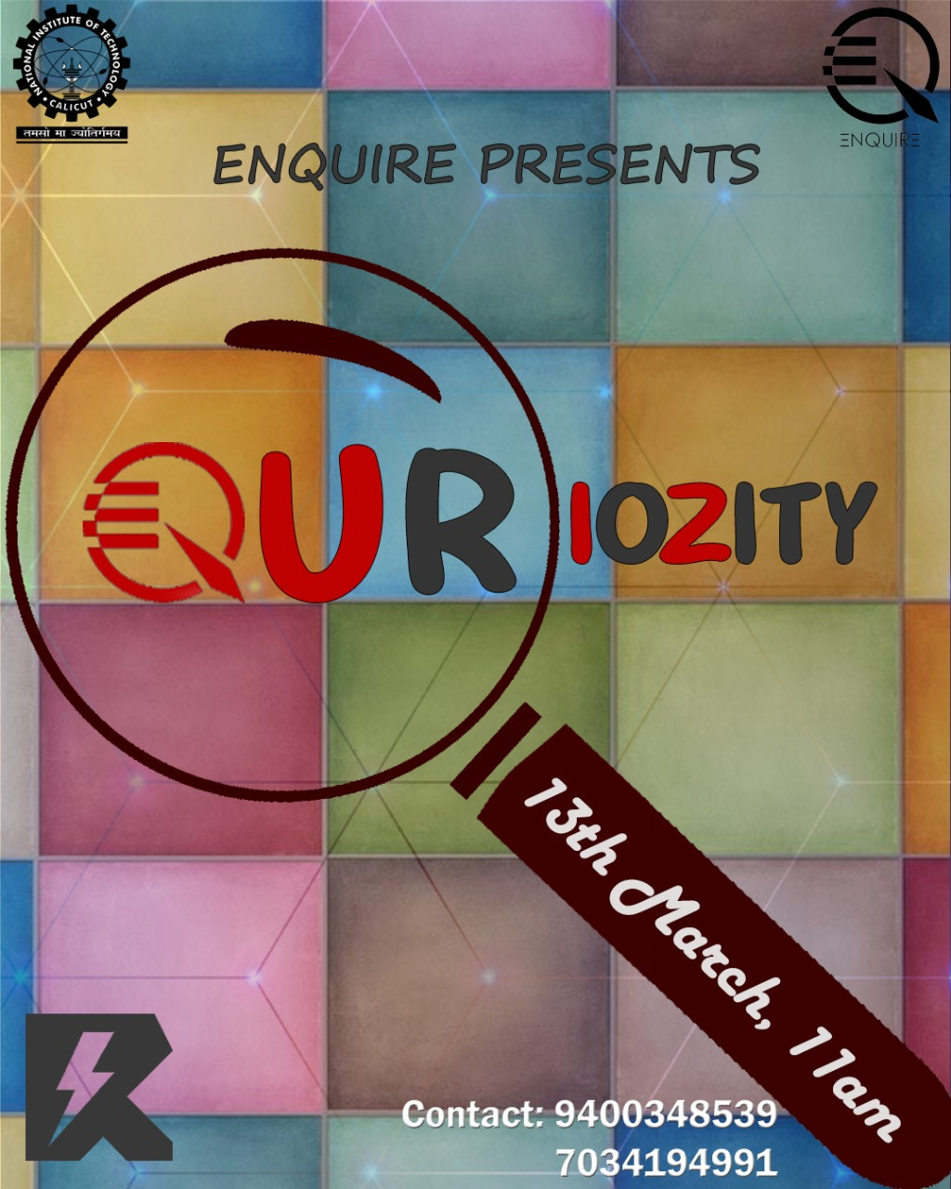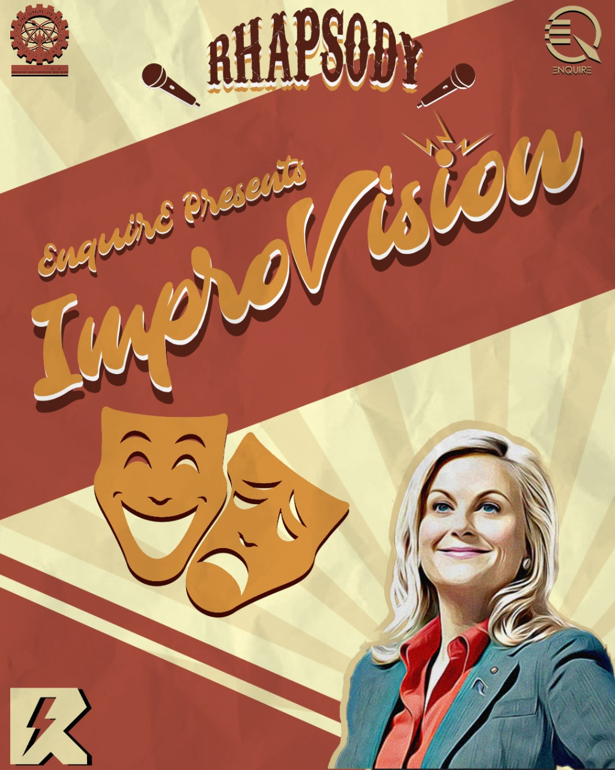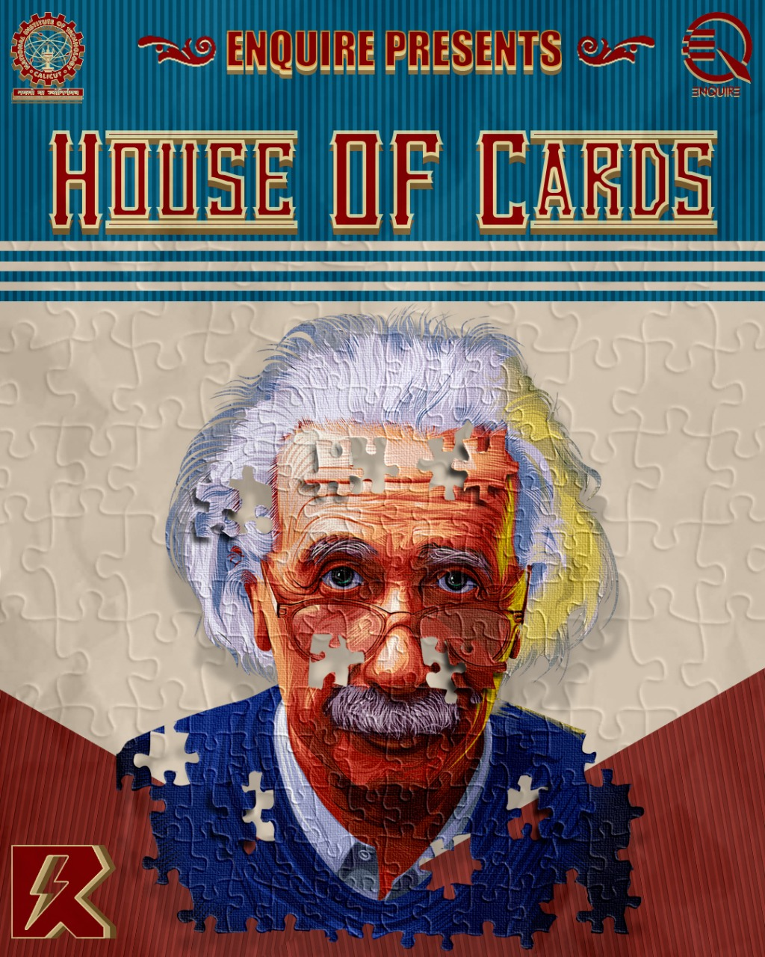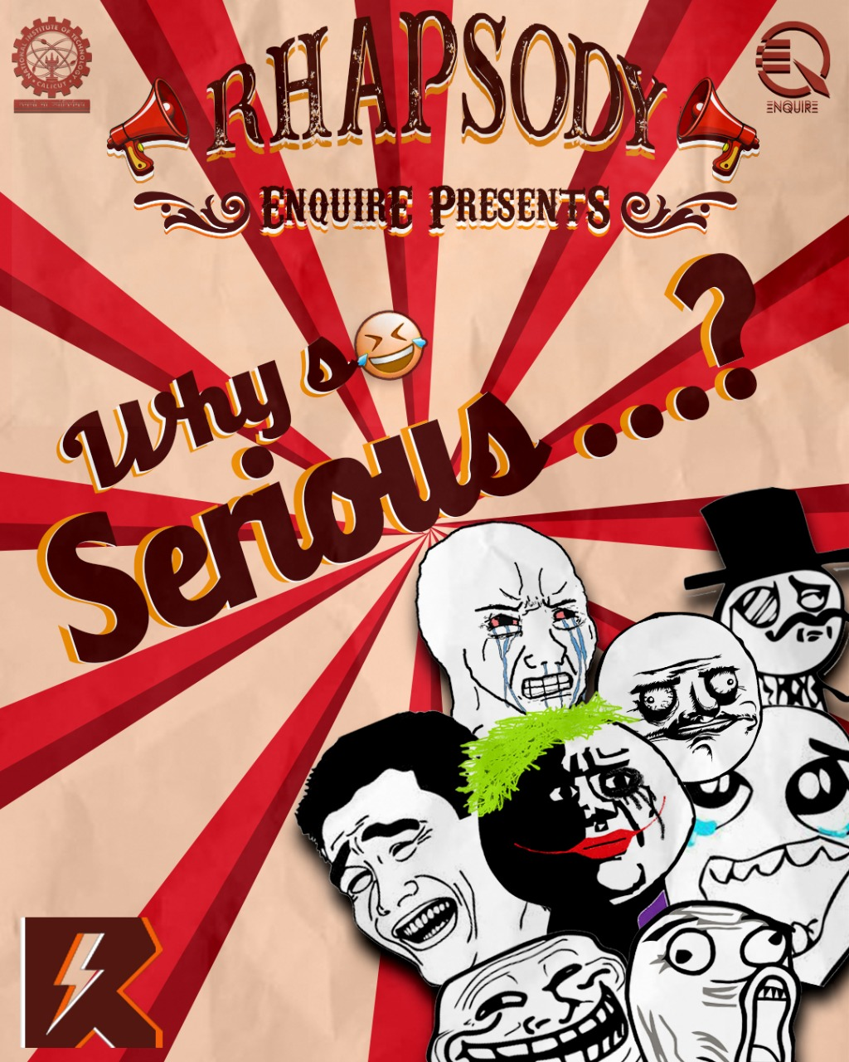

“Quriosity” was a classic quiz competition. The prelims were conducted using Google forms. The final round was conducted via Google meet to make it as lively as possible.

We have also conducted a “Reverse quiz”, which was one of its kind. In this competition, we have given the answers to the participants and the winners were declared based on the quality of the questions they made.

“House of Cards” was a play with images, the picture assigned to a team should be identified based on the clues that are given on solving questions.

For the non-quizzers, we have coordinated “Improvision”, an improv competition, and “Why so serious…?”, a meme-making competition. The feedback from our first years was fabulous and it has helped us to build a huge rapport with them.

We also conducted occasional quizzes to keep the audience of our club engaged and informed regarding different aspects of knowledge.

Along with our traditional quizzes, this year onwards we are also looking forward to posting different articles occasionally regarding a wide range of topics and enthusiastic to bring out dire and diverse content which are informative on the one hand and entertaining as well on the other.